**SUPPORT VECTOR MACHINE(SVM)**

We have got points in 2-D space(i.e 2 columns in dataset, x1 and x2). We have got some observation points that are red and green, that means they are already classified.

How to separate these points so that the decision boundary can help us when we add new data points.

One simple way – draw a line in between (vertical, horizontal or diagonal lines)

But all will have different consequences. Thereforewe have to find an optimal line.

So, with the help of SVM , line is searched through Maximum margin.

Basically, maximum margin is a line that separates the 2 classes of points and at the same time it has the maximum margin, i.e this line is equidistant from the two points called support vectors. The sum of these distances has to be maximized.

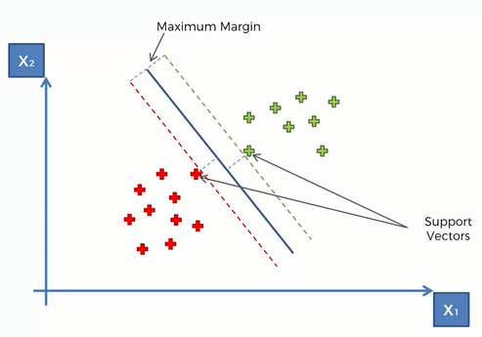Only these two points contribute to the result of the algorithm, rest all points does not matter(even if they are changed)

Therefore these two points are called supporting vectors.

[And these are not points, these are vectors because in a multidimensional space when you have more than 2 variables, each point is actually a vector.]

Maximum Margin Line is called Hyperplane(or Maximum Margin Classifier)

There is a positive and negative hyperplane also.

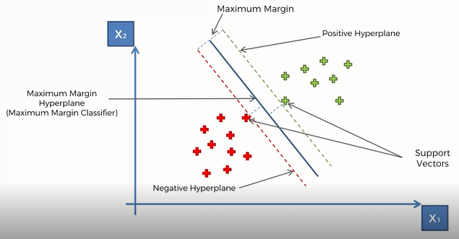[Usually we name right one as positive and the left one as negative]

Why SVM is special?

-> For example you are telling a machine how to classify between an apple and an orange. First the machine determines different elements of both apple and orange and then it is given an apple or an orange to classify whether it is apple or orange.

Let there is an orange coloured apple and a green coloured orange.

So, these two act as supporting vectors.